WEEK 5 - KAFKA CHAT BOX
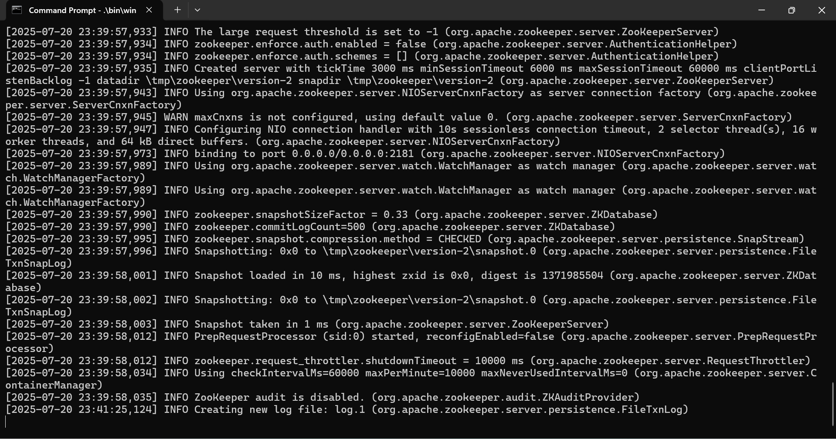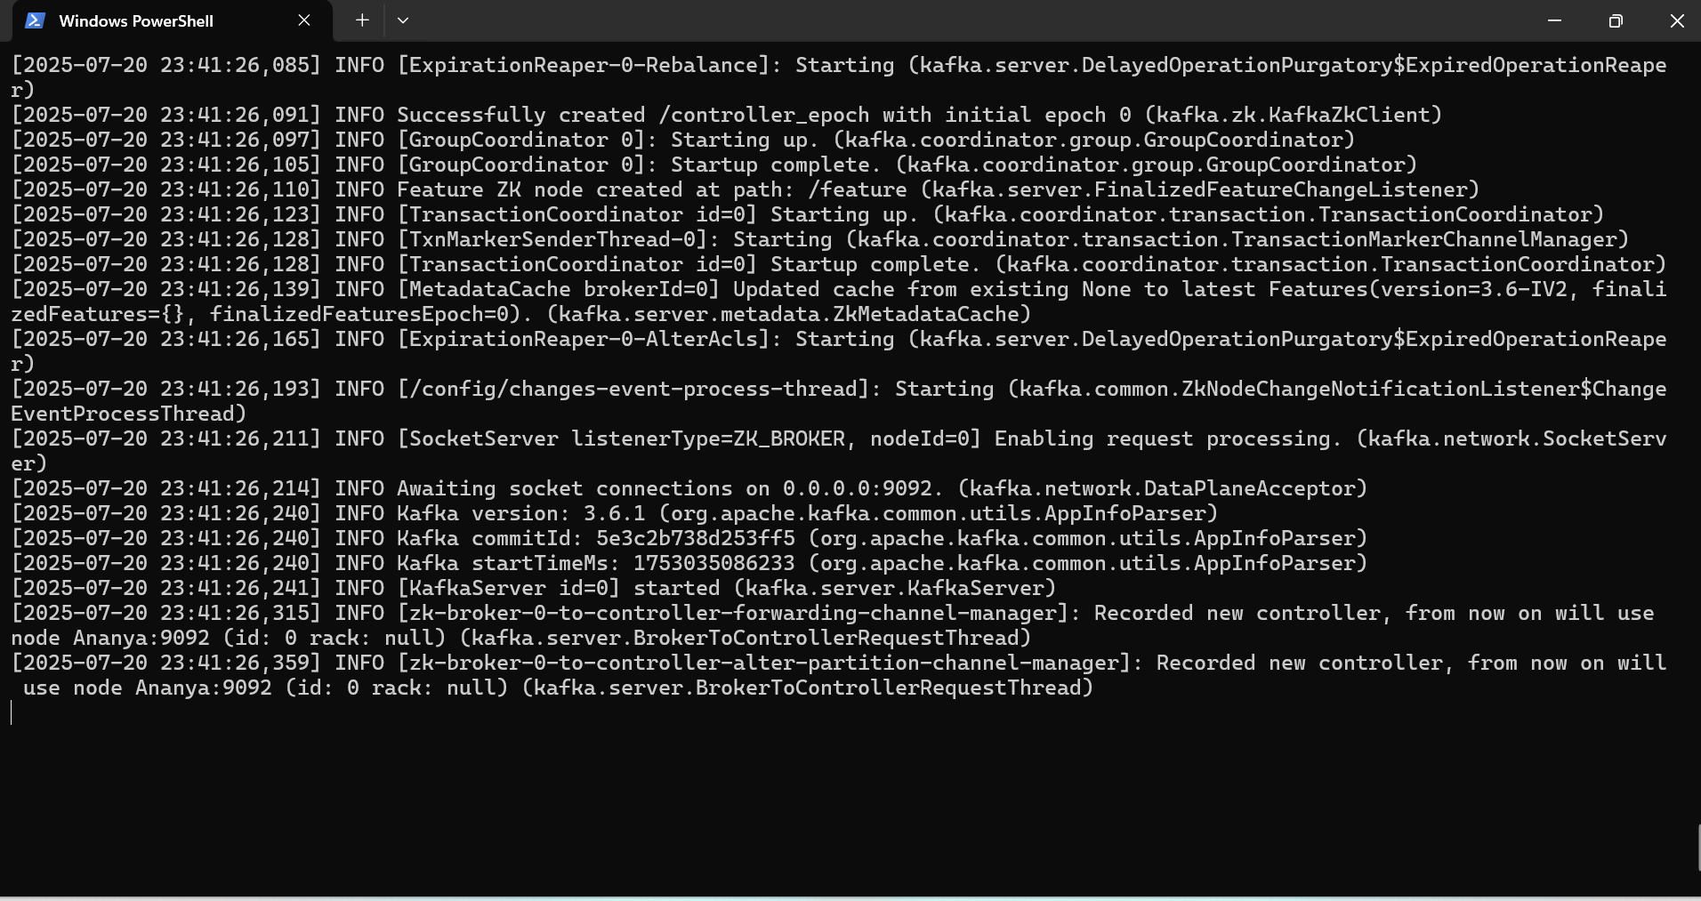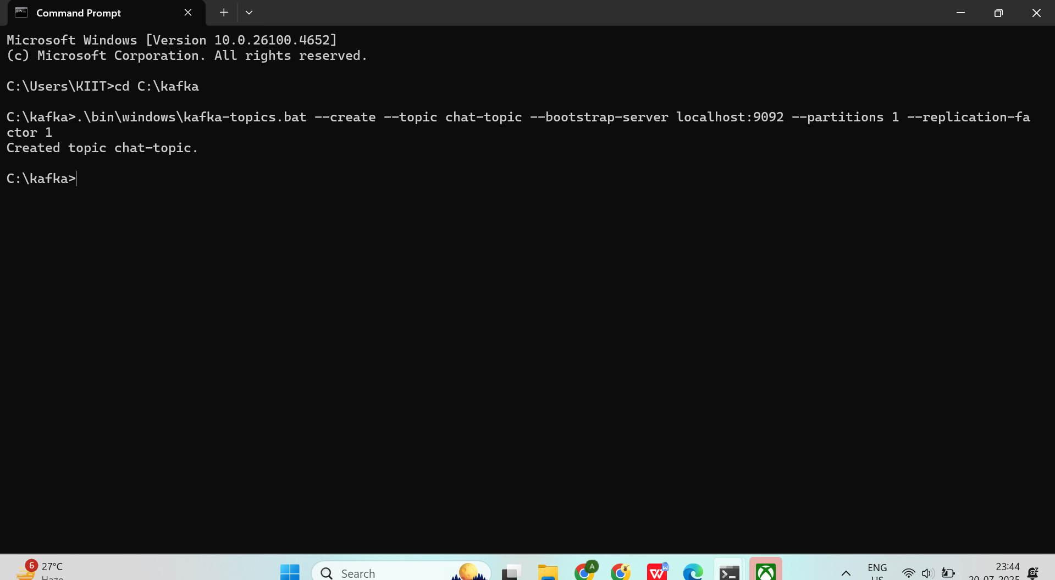
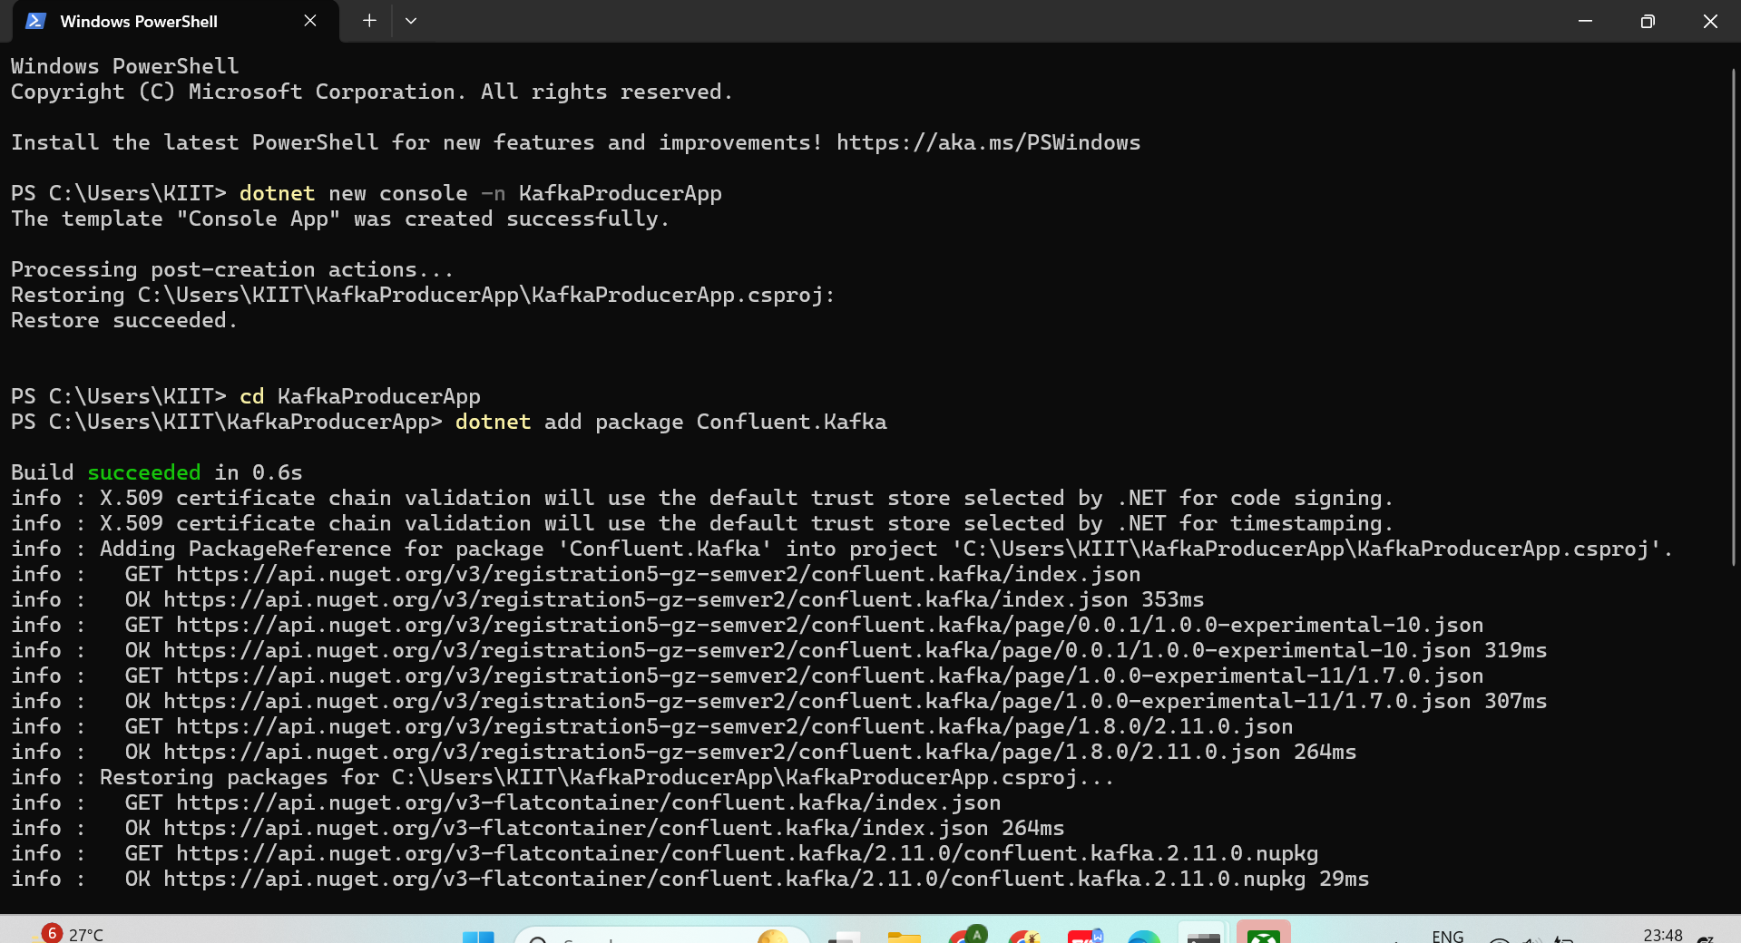

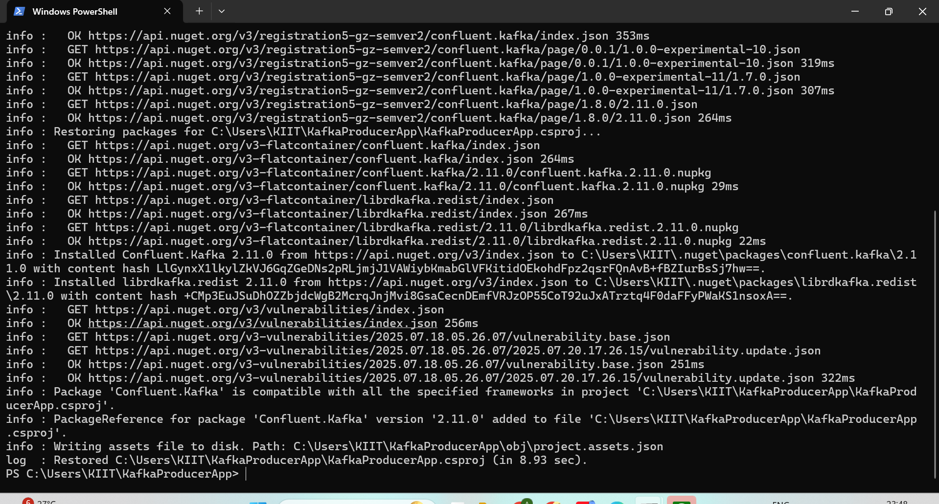

PROGRAM.CS (PRODUCERAPP)

using Confluent.Kafka;

var config = new ProducerConfig { BootstrapServers = "localhost:9092" };

using var producer = new ProducerBuilder<Null, string>(config).Build();

Console.WriteLine("=== Kafka Producer Chat ===");
Console.WriteLine("Type a message and press [Enter] to send:");

while (true)
{
Console.Write("You: ");
var input = Console.ReadLine();
if (string.IsNullOrWhiteSpace(input)) continue;

await producer.ProduceAsync("chat-topic", new Message<Null, string> { Value = input });
}

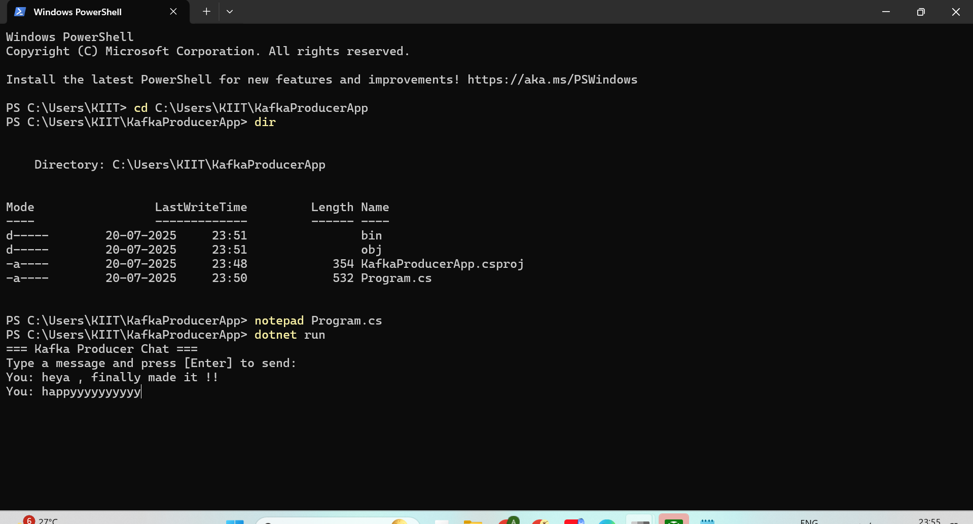
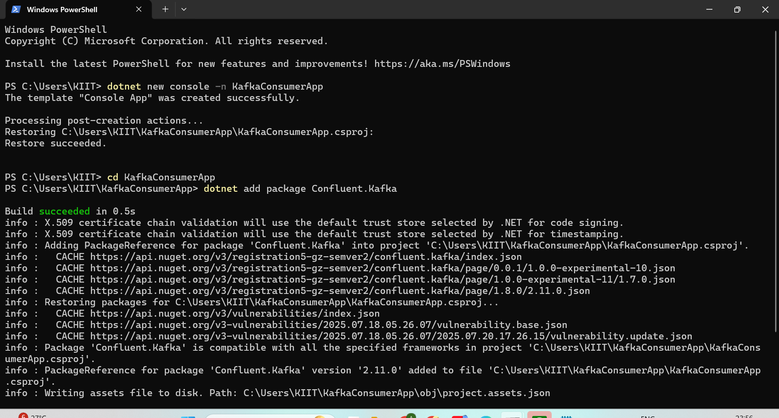
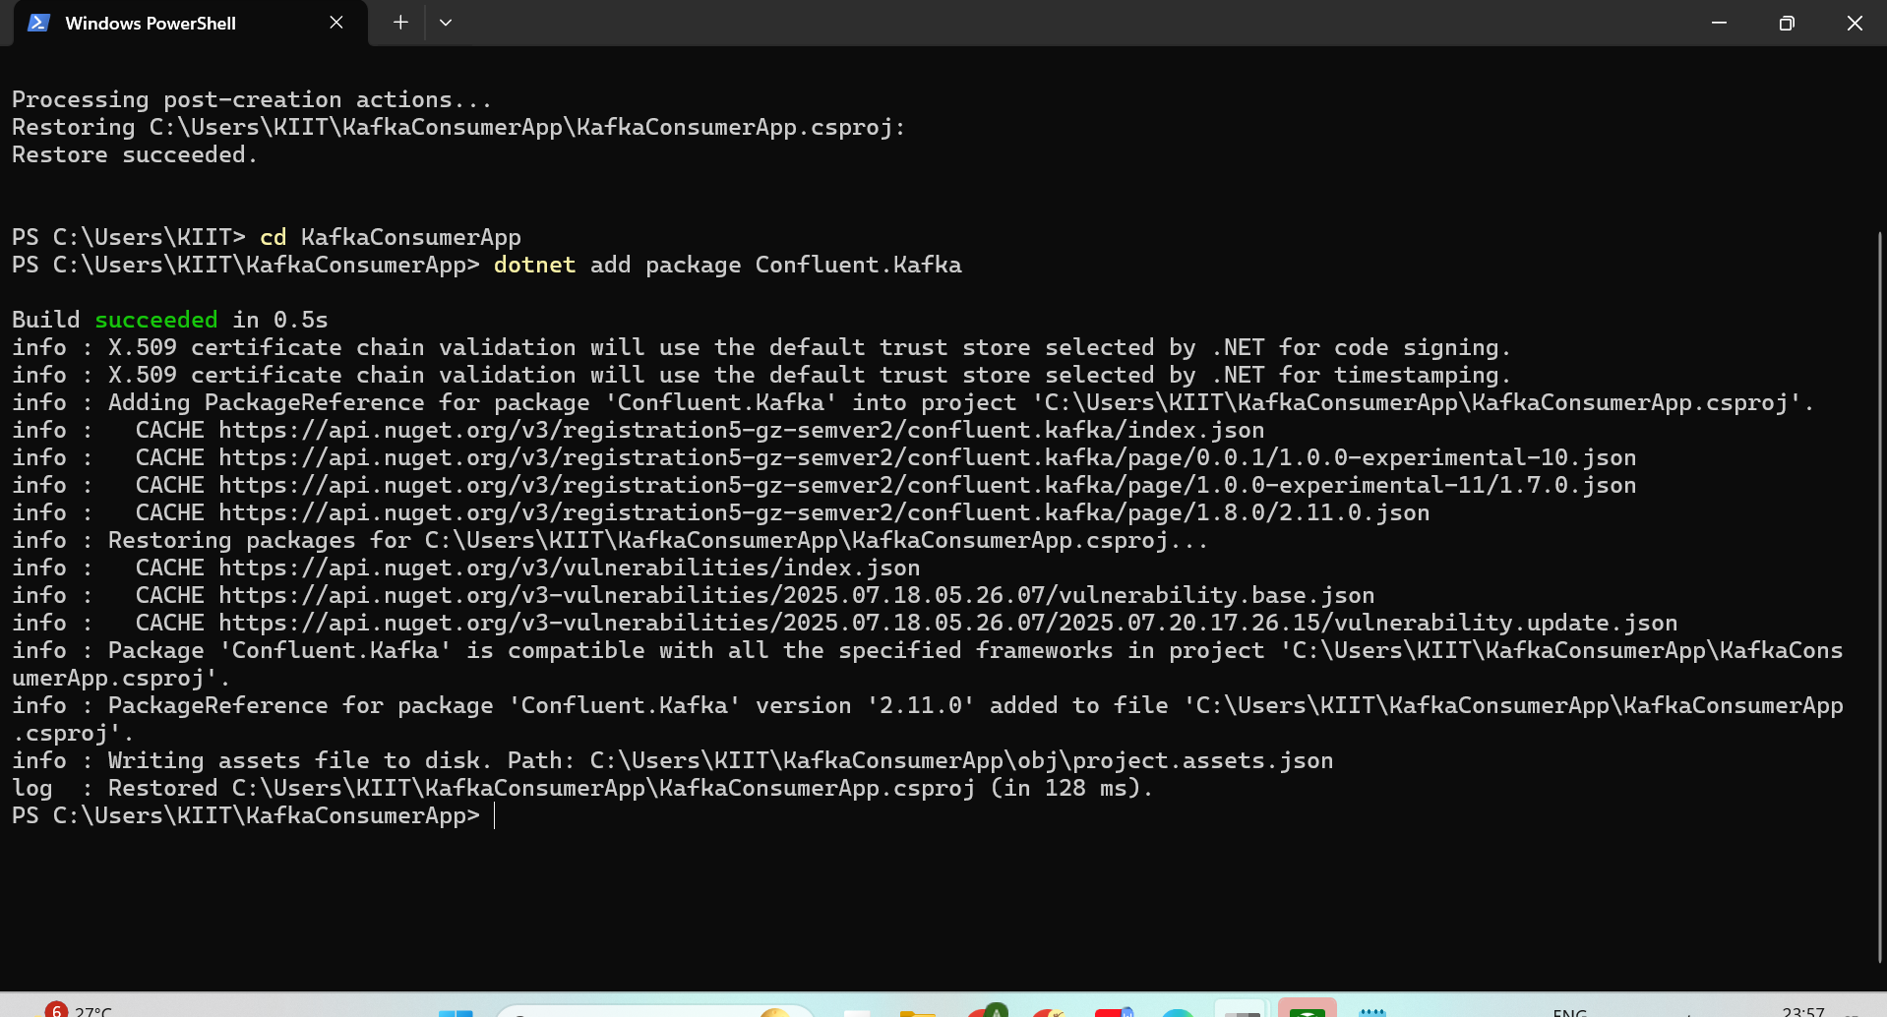

PROGRAM.CS (CONSUMERAPP)

using Confluent.Kafka;

var config = new ConsumerConfig
{
BootstrapServers = "localhost:9092",
GroupId = "chat-consumer-group",
AutoOffsetReset = AutoOffsetReset.Earliest
};

using var consumer = new ConsumerBuilder<Null, string>(config).Build();
consumer.Subscribe("chat-topic");

Console.WriteLine("=== Kafka Consumer Chat ===");
Console.WriteLine("Waiting for messages...");

while (true)
{
var result = consumer.Consume();
Console.WriteLine($"\n👀 Friend: {result.Value}");
}

